Data Base Lab04

Group members: Liang Haoxuan, Liu Sihan, Wang Changpeng

Basic Tasks

1/2/3/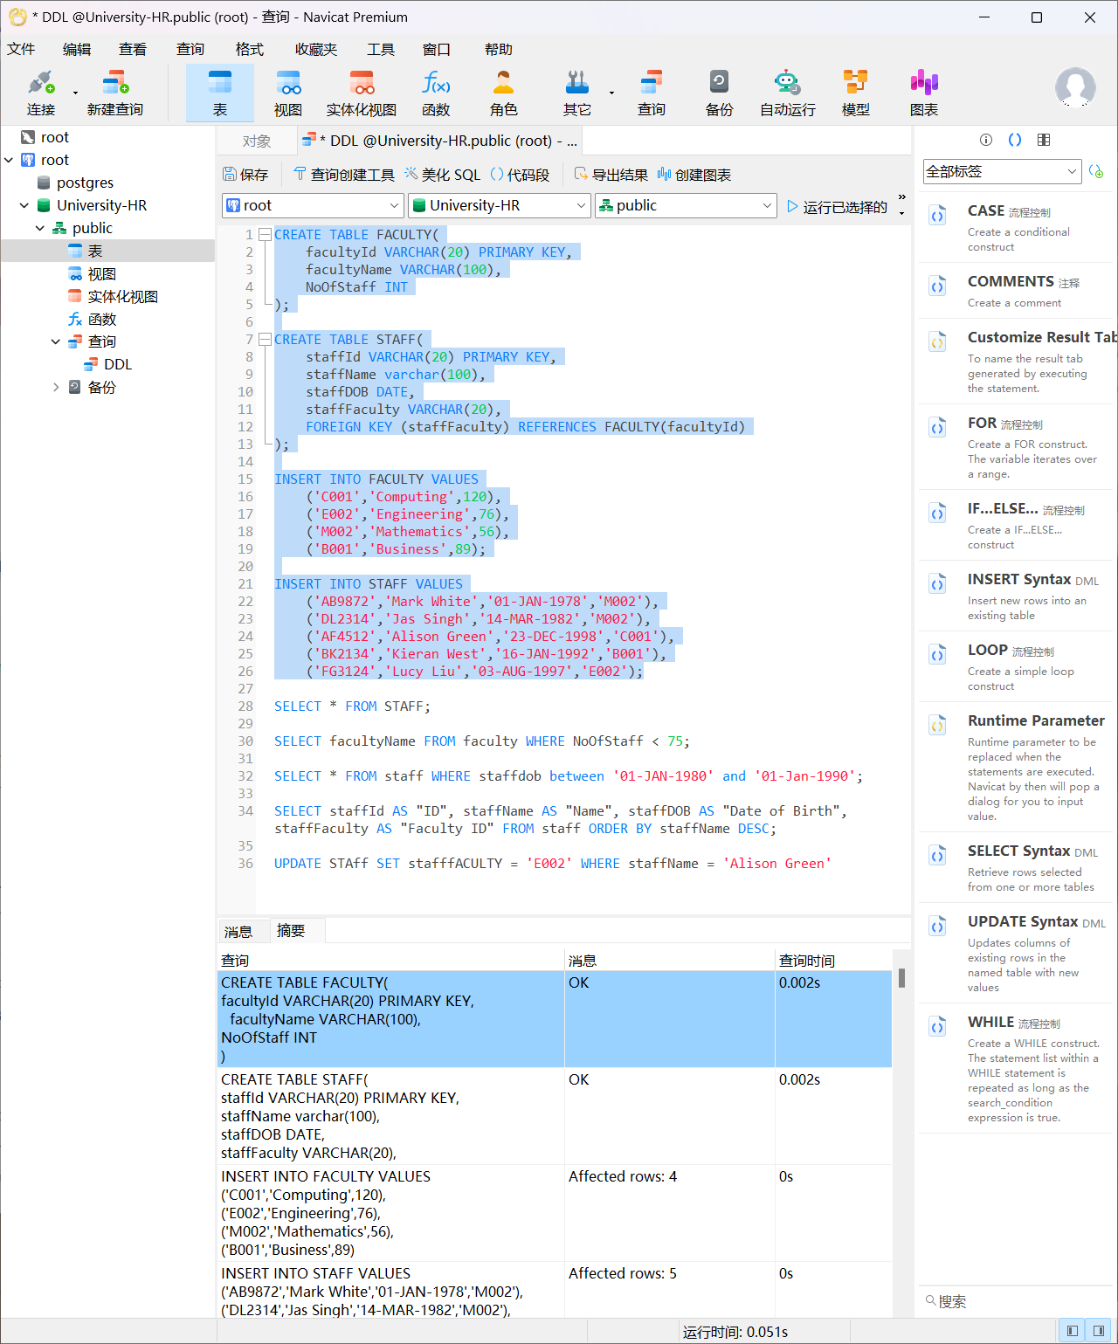

4/

a/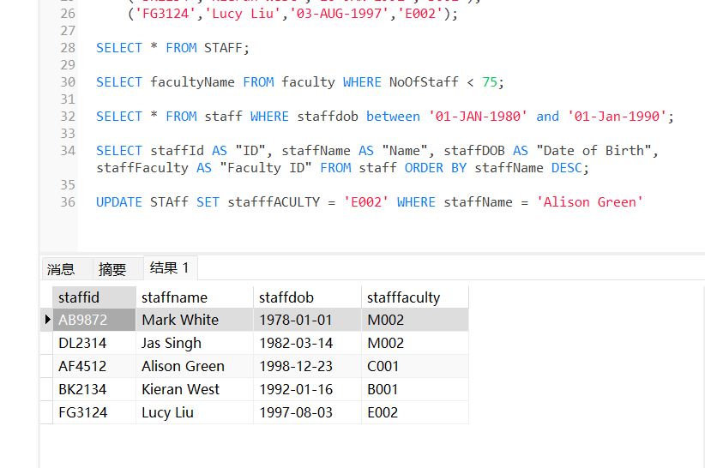

b/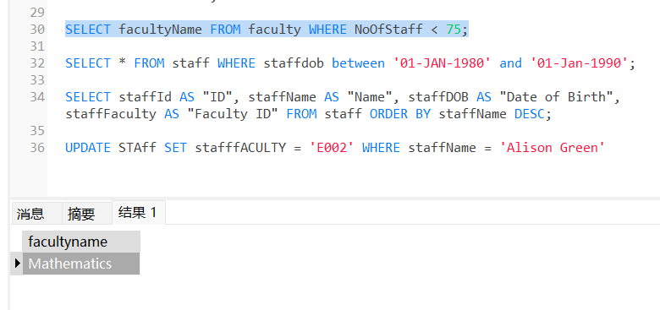

c/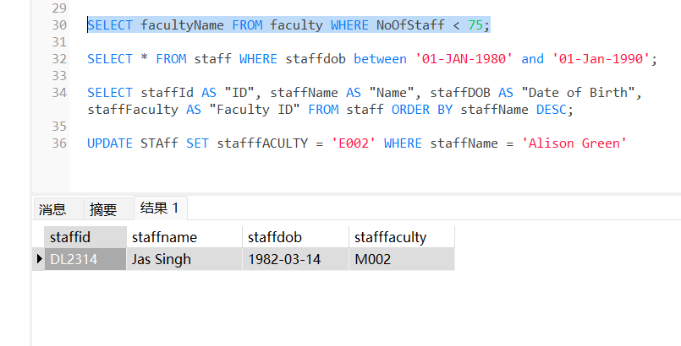

d/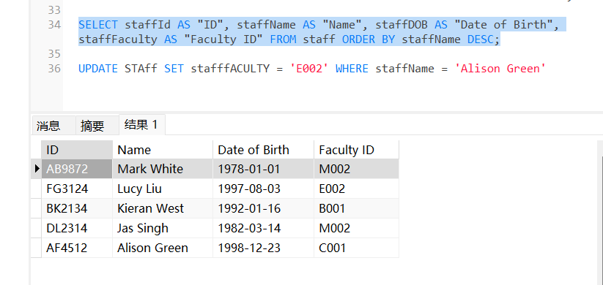

e/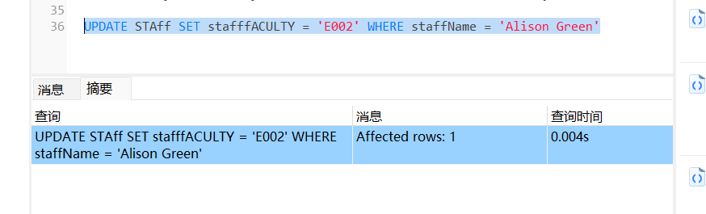

f/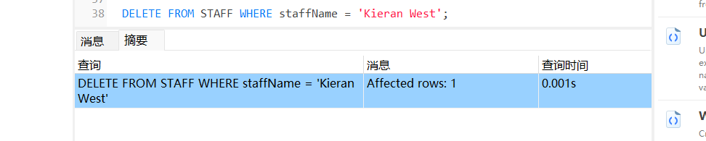

Medium Tasks

5/

CREATE TABLE CUSTOMER (

custId DECIMAL(10) PRIMARY KEY,

address VARCHAR(30),

city VARCHAR(20),

custTypeCd VARCHAR(1) NOT NULL,

fedId VARCHAR(12) NOT NULL,

postalCode VARCHAR(10),

state VARCHAR(20)

);

CREATE TABLE BRANCH (

branchId DECIMAL(10) PRIMARY KEY,

address VARCHAR(30),

city VARCHAR(20),

name VARCHAR(20) NOT NULL,

state VARCHAR(12),

zipCode VARCHAR(10)

);

CREATE TABLE DEPARTMENT (

deptId DECIMAL(10) PRIMARY KEY,

name VARCHAR(20) NOT NULL

);

CREATE TABLE EMPLOYEE (

empId DECIMAL(10) PRIMARY KEY,

endDate DATE,

firstName VARCHAR(20) NOT NULL,

lastName VARCHAR(20) NOT NULL,

startDate DATE,

title VARCHAR(20),

assignedBranchId DECIMAL(10),

deptId DECIMAL(10),

superiorEmpId DECIMAL(10),

FOREIGN KEY (assignedBranchId) REFERENCES BRANCH (branchId),

FOREIGN KEY (deptId) REFERENCES DEPARTMENT (deptId),

FOREIGN KEY (superiorEmpId) REFERENCES EMPLOYEE (empId)

);

CREATE TABLE PRODUCT_TYPE (

productTypeCd VARCHAR(255) PRIMARY KEY,

name VARCHAR(50)

);

CREATE TABLE PRODUCT (

productCd VARCHAR(10) PRIMARY KEY,

dateOffered DATE,

dateRetired DATE,

name VARCHAR(50) NOT NULL,

productTypeCd VARCHAR(255),

FOREIGN KEY (productTypeCd) REFERENCES PRODUCT_TYPE (productTypeCd)

);

CREATE TABLE ACCOUNT (

accountId INT PRIMARY KEY,

availBalance DECIMAL(14, 2),

closeDate DATE,

lastActivityDate DATE,

openDate DATE NOT NULL,

pendingBalance DECIMAL(14, 2),

status VARCHAR(10),

custId DECIMAL(10),

openBranchId DECIMAL(10) NOT NULL,

openEmpId DECIMAL(10) NOT NULL,

productCD VARCHAR(10) NOT NULL,

FOREIGN KEY (custId) REFERENCES CUSTOMER (custId),

FOREIGN KEY (openBranchId) REFERENCES BRANCH (branchId),

FOREIGN KEY (openEmpId) REFERENCES EMPLOYEE (empId),

FOREIGN KEY (productCD) REFERENCES PRODUCT (productCd)

);

CREATE TABLE ACC_TRANSACTION (

txinId INT PRIMARY KEY,

amount DECIMAL(14, 2) NOT NULL,

fundsAvailDate TIMESTAMP NOT NULL,

txin_Date TIMESTAMP NOT NULL,

txinTypeCd VARCHAR(10),

accountId INT,

executionBranchId DECIMAL(10),

tellerEmpId DECIMAL(10),

FOREIGN KEY (accountId) REFERENCES ACCOUNT (accountId),

FOREIGN KEY (executionBranchId) REFERENCES BRANCH (branchId),

FOREIGN KEY (tellerEmpId) REFERENCES EMPLOYEE (empId)

);

CREATE TABLE BUSINESS (

custId DECIMAL(10) PRIMARY KEY NOT NULL,

incorpDate DATE,

name VARCHAR(255) NOT NULL,

stateId VARCHAR(10) NOT NULL,

FOREIGN KEY (custId) REFERENCES CUSTOMER (custId)

);

CREATE TABLE INDIVIDUAL (

custId DECIMAL(10) PRIMARY KEY,

birthDate DATE,

firstName VARCHAR(30),

lastName VARCHAR(30),

FOREIGN KEY (custId) REFERENCES CUSTOMER (custId)

);

CREATE TABLE OFFICER (

officerId DECIMAL(10) PRIMARY KEY,

endDate DATE,

firstName VARCHAR(30) NOT NULL,

lastName VARCHAR(30) NOT NULL,

startDate DATE NOT NULL,

title VARCHAR(20),

custId DECIMAL(10),

FOREIGN KEY (custId) REFERENCES CUSTOMER (custId)

);

SELECT table_name FROM information_schema.tables WHERE table_schema = 'public';

